Lbumin

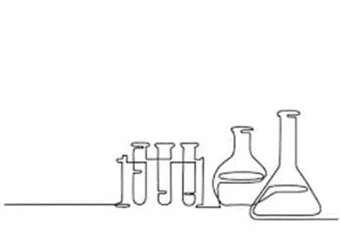

# Serum Albumin (Bromocresol Green Method)

Aims: To perform serum albumin determinations on samples, explain the principle behind the Bromocresol Green method for albumin measurement and to list the factors that will cause interference with this method.

### Principle:

Albumin is known for its ability to bind many types of organic compounds, including organic dyes. When albumin selectively binds with Bromcresol Green (BCG) it causes a change in the absorbance maximum of BCG. The intense blue-green complex that is formed has an absorbance max of 670nm. Bromocresol reagent at pH 4.3 is negatively charged. The pI of albumin is 4.7.

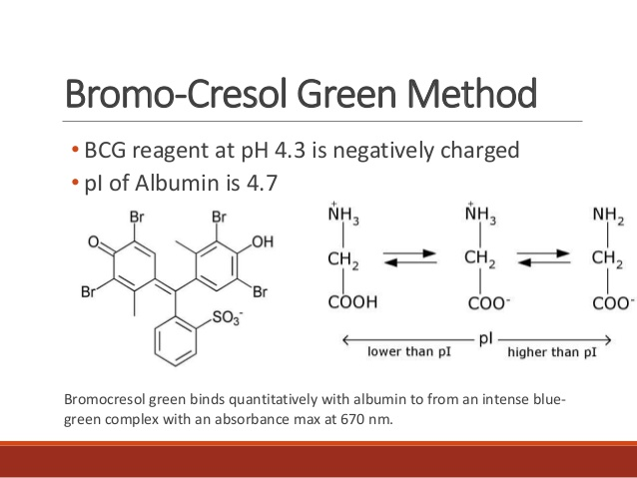

For all spectrometric assays, always use a **Reagent blank**. It usually contains all diluents and reagent in the reaction solution, but no sample. Some reagent blanks do contain the sample as well, but they lack one crucial reagent component needed to produce a colour-yielding reaction. This is different from the water used to zero a spectrophotometer (set 100% T).

### Materials:

1. Albumin Stock Solution (100g/L) or Cobas calibrator
2. Serum patient samples (record the albumin results off track)
3. Cobas albumin controls
4. Bromocresol green reagent (BCG) - obtain Cobas reagent or make up as follows:

* 7.5mg of BCG
* 250mg EDTA
* 250µL Tween 20
* Bring up to 25mL with water

### Methods:

1. Generate a calibration curve of at least 8 standards (0- 80 g/L) by diluting the Albumin Stock (100 g/L).
2. In labelled tubes, set up a calibration, controls and test samples as follows:

|  |  |  |  |  |  |
| --- | --- | --- | --- | --- | --- |
| Sample | Water (µL) | Std (µL) | Control (µL) | Sample (µL) | BCG Reagent (µL) |
| Blank | 310 | - | - | - | 300 |
| Calibrators | 300 | 10 | - | - | 300 |
| Control | 300 | - | 10 | - | 300 |
| Serum Sample | 300 | - | - | 10 | 300 |

1. Mix well read immediately at 630nm and record absorbances
2. Plot a standard curve and determine experimental concentrations of controls and serum samples
3. Compare results to expected results and comment on any differences between the manual BCG vs automated BCP assays
4. A haemolysed sample is brought to the laboratory for albumin analysis. Can the sample be used? Discuss.
5. Why is it not desirable to incubate the reaction before measuring the absorbance?
6. Some analyzers can measure the absorbance of the BCG reaction within 30 seconds after adding sample. Does this tend to increase the specificity of the reaction?